**Kingdom of Saudi Arabia**



**Ministry of Education**

**Prince Sattam Bin Abdul-Aziz University**

**College of Computer Engineering and Sciences**

**Department of IS**

**BANA SYSYTEM**

****SYSTEM ANALYSIS AND DESIGN

**Students name:**

Ameerh Hassan Aldossiry

Munira Aldaej

Aliyah Alotibi

**Report submission Supervisor:**

T: Noura Almohasin

**1444 AH**

**Project Summary**

The delivery industry is rapidly growing in Saudi Arabia, with businesses of all sizes relying on efficient and reliable delivery management systems to meet the needs of their customers. To address this growing demand, we propose the development of a delivery management system for Saudi Arabia, Our system, which we will call "Bana," will provide businesses with an end-to-end solution for managing delivery orders, dispatching drivers, tracking deliveries, and communicating with customers. By streamlining the delivery process and improving efficiency, Nana will help businesses meet the needs of their customers and remain competitive in the Saudi Arabian market. In this project, we will define the requirements for the Bana system, choose the appropriate technology stack, develop the system, test and refine it, and launch it for use in Saudi Arabia.

**Agile Methodologies Approach:p**

When we create a application Bana, We used agile methodologies because the Agile Methodologies Approach is well-suited for the development of a complex project like the Bana order delivery systemas it allows for flexibility, collaboration, continuous delivery, customer satisfaction, and risk reduction. By following the Agile approach, the development team can ensure that the system is developed efficiently, effectively, and in a way that meets the needs of businesses and customers in Saudi Arabia.

# The advantage

* High-quality code
* Focuses on customer requirements
* High level of productivity
* Simplicity in design and coding

**Planning Phase :**

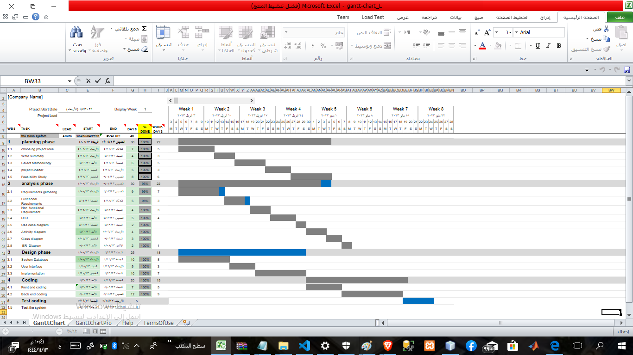***Gantt chart :***

**Feasibility Study**

**Economic Feasibilty Study:**

The economic feasibility study is an important component of our overall feasibility study for the development of the Bana delivery system in Saudi Arabia. In this study, we will assess the tangible and intangible costs and benefits of developing and operating the system.

**Tangible and intangible costs:**

|  |  |
| --- | --- |
| **Tangible Costs** | **Intangible Costs Web** |
| **Network devices costs** | hosting and domain |
| **Data base costs** | Software of programming and design costs |
|  | Online Marketing |

Tangible and intangible benfits:

* Tangible Benefits:

1. Increased Revenue: The Bana delivery system has the potential to increase revenue for businesses by providing a more efficient and reliable delivery service.

2. Cost Savings: The Bana delivery system has the potential to reduce costs for businesses by streamlining the delivery process and reducing the need for manual processes.

3. Improved Customer Satisfaction: The Bana delivery system has the potential to improve customer satisfaction by providing real-time tracking, faster delivery times, and better communication

# Intangible Benefits:

1. Brand Recognition: The Bana delivery system has the potential to increase brand recognition for businesses by providing a high-quality delivery service.

2. Competitive Advantage: The Banadelivery system has the potential to provide a competitive advant.age for businesses by offering a unique and innovative delivery service.

3. Social Impact: The Bana delivery system has the potential to have a positive social impact by creating job opportunities for drivers and supporting the growth of small businesses.

**Social Feasibility Study:**

a social feasibility study would be important to ensure that the development of the Bana delivery system in Saudi Arabia is socially responsible and sustainable. The study would identify any potential challenges and help to develop strategies to address them, ultimately contributing to the success of the project.

**Technical feasibility:**

The team has an excellent background in application development.

General rules emerged as technical risk assesments:

|  |  |  |  |
| --- | --- | --- | --- |
|  | | Low structure | High structure |
| High familiarity with  technology | Large project | Low Risk | Low Risk |
| Small project | Very low risk | Very low Risk |
| Low familiaritywith  technology | Large project | HighRisk  Very | MediumRisk |
| Small project | High Risk | Medium-low  Risk |

|  |  |  |  |  |  |
| --- | --- | --- | --- | --- | --- |
| *PROJECT CHARTER* | | | | | |
| **PROJECT**  **TITLE** | **Bana APPLICATION** | | | **PROJECT**  **MANGER** | **Ameerh Aldossiry** |
| **PROJECT**  **START DAY** | **5/4/23** | **PROJECT**  **ENDDAY** | **28/5/23** | **PROJECT**  **RESPONSE** | **Aliyah Alotaibi** |
| ***BUSINESS NEED*** | | | | | |
| **When a customer wants to order online to save time and effort, or to create a new environment for shop owners or restaurants to market and sell their products online, this project was created to facilitate the matter and save time by allowing the customer to view and order products online, and to allow shop owners and restaurants to present their products.** | | | | | |
| ***PROJECT SCOPE*** | | | ***DELIVERABLES*** | | |
| **Bana is a delivery application that serves people who want to order products online in the Kingdom of Saudi Arabia** | | | **Web-version** | | |
| **RISKS AND ISSUES** | | | **ASSUMPTIONES/DEPENDENCIES** | | |
| **Requirements are not easily obtained and structure .** | | | **Manager to provide regular updates for the project .** | | |
| **FINANCILAS** | | | | | |
| **The budget to complete this project is 2500$** | | | | | |
| ***PROJECT TEAM*** | | |  | | |
| **PROJECT**  **MANAGER** | | | **Ameerh Aldossiry** | | |
| **PROJECT**  **MANAGER** | | | **Aliyah Alotaibi** | | |
| **PROJECT**  **MANAGER** | | | **Munira Aldaej** | | |

**Analysis Phase:**

**Requirements gathering**

We worked as one team on the project Idea to discuss and define the project requirements:

**First**: Determine the system's ability to respond quickly. **Second**: Determine system services.

**Third**: Determine the clients of the system.

We visited various websites to gather information about defining and developing project requirements.

**functional requirements**

**Customers:**

**1.1** Customers should be able to create an account on the bana system with their personal and contact information.

**1.2** The system should provide customers with a way to verify their accounts, such as through email or SMS verification.

**1.3** Customers should be able to sign in to their account to access their order history and other account information.

**1.4** Customers should be able to search and for restaurants or stores based on location, cuisine, and ratings and its prices

**1.5** Customer should be able to view their menus and products.

**1.6** Customers should be able to add items to their cart.

**1.7** Customers should be able to insert places of delivery of the order

1.8 Customers should be able to cancel their orders before they are processed.

1.9 Customers should be able to make payments for their orders using different payment methods, including credit cards, debit cards, and mobile payment apps.

**1.10** Customers should be able to make payments for their orders using Points available in their wallets in the bana system

**1.11** Customers should receive their orders in a timely and efficient manner, with real-time updates on the status of their orders and the location of the delivery driver using GPS.

**1.12** Customers should be able to communicate with driver

**1.13** Customers should be able to view the estimated delivery time for their orders.

**1.14** Customers should be able to access customer service support through different channels, including phone, email, and live chat, to get assistance with their orders and inquiries

**1.15** Customers should be able to view their order history.

**1.16** Customers should be able to rate restaurants and leave feedback on their experience

**2. Customer Service:**

**2.1** Customer service representatives should be able to manage customer complaints

**2.2** Customer service representatives should be able to track the status of orders.

**2.3** Customer service representatives should be able to provide updates to customers.

**2.4** Customer service representatives should be able to provide refunds and discounts to customers when necessary.

**2.5** Customer service representatives should be able to manage customer accounts and update their information.

**2.6** Customer service representatives should be able to respond to customer inquiries and provide support.

**3. Delivery Drivers:**

**3.1** The delivery driver must register with the bana system by providing their personal information, vehicle details, and other relevant information.

**3.2** Delivery drivers should be able to view details of the orders they are assigned to.

**3.3** Delivery drivers should be able to navigate to the delivery location using GPS

**3.4** Delivery drivers should be able to update the status in real-time.

**4 Stores/Restaurants:**

**4.1** The bana system may require stores/restaurants to register in order to access the platform.

**4.2** stores/restaurants should be able to provide basic information about the store/restaurant, including ( the name, address, contact information, and business hours. )

**4.3** Stores/restaurants should be able to update their menus with new items or changes.

**4.4** Stores/restaurants should be able to receive orders.

**Non-functional requirements**

**• Performance**

The Application load time should not be more than one second for users.

**• Scalability**

The system shall design to deal with the increasing use and any size of data without errors.

**• Reliability**

The system should take the minimum time to work correctly and deliver the results.

Usability

Application interfaces should be user-friendly.

Application should be easy to use by all kinds of users without training or help

**Use case**

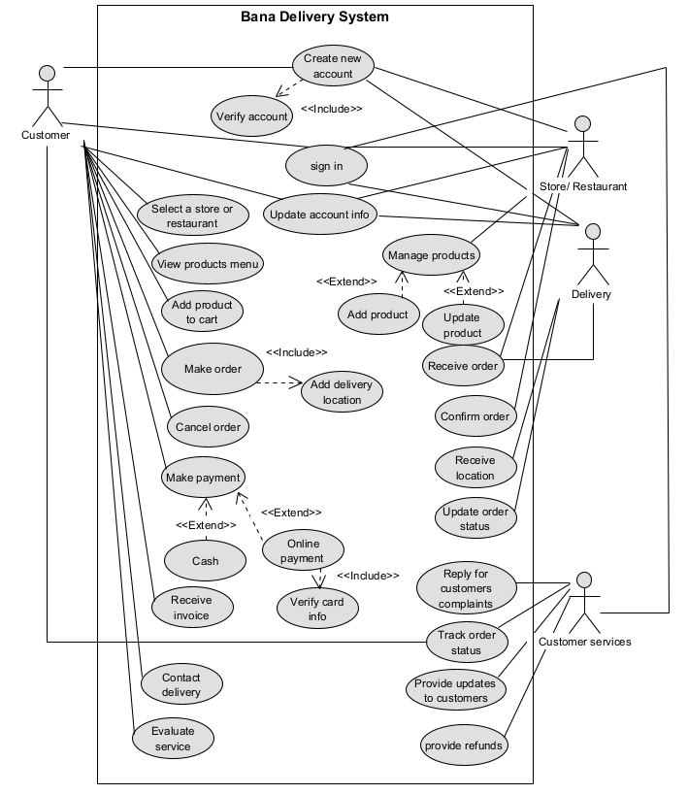

**Activity diagramj**

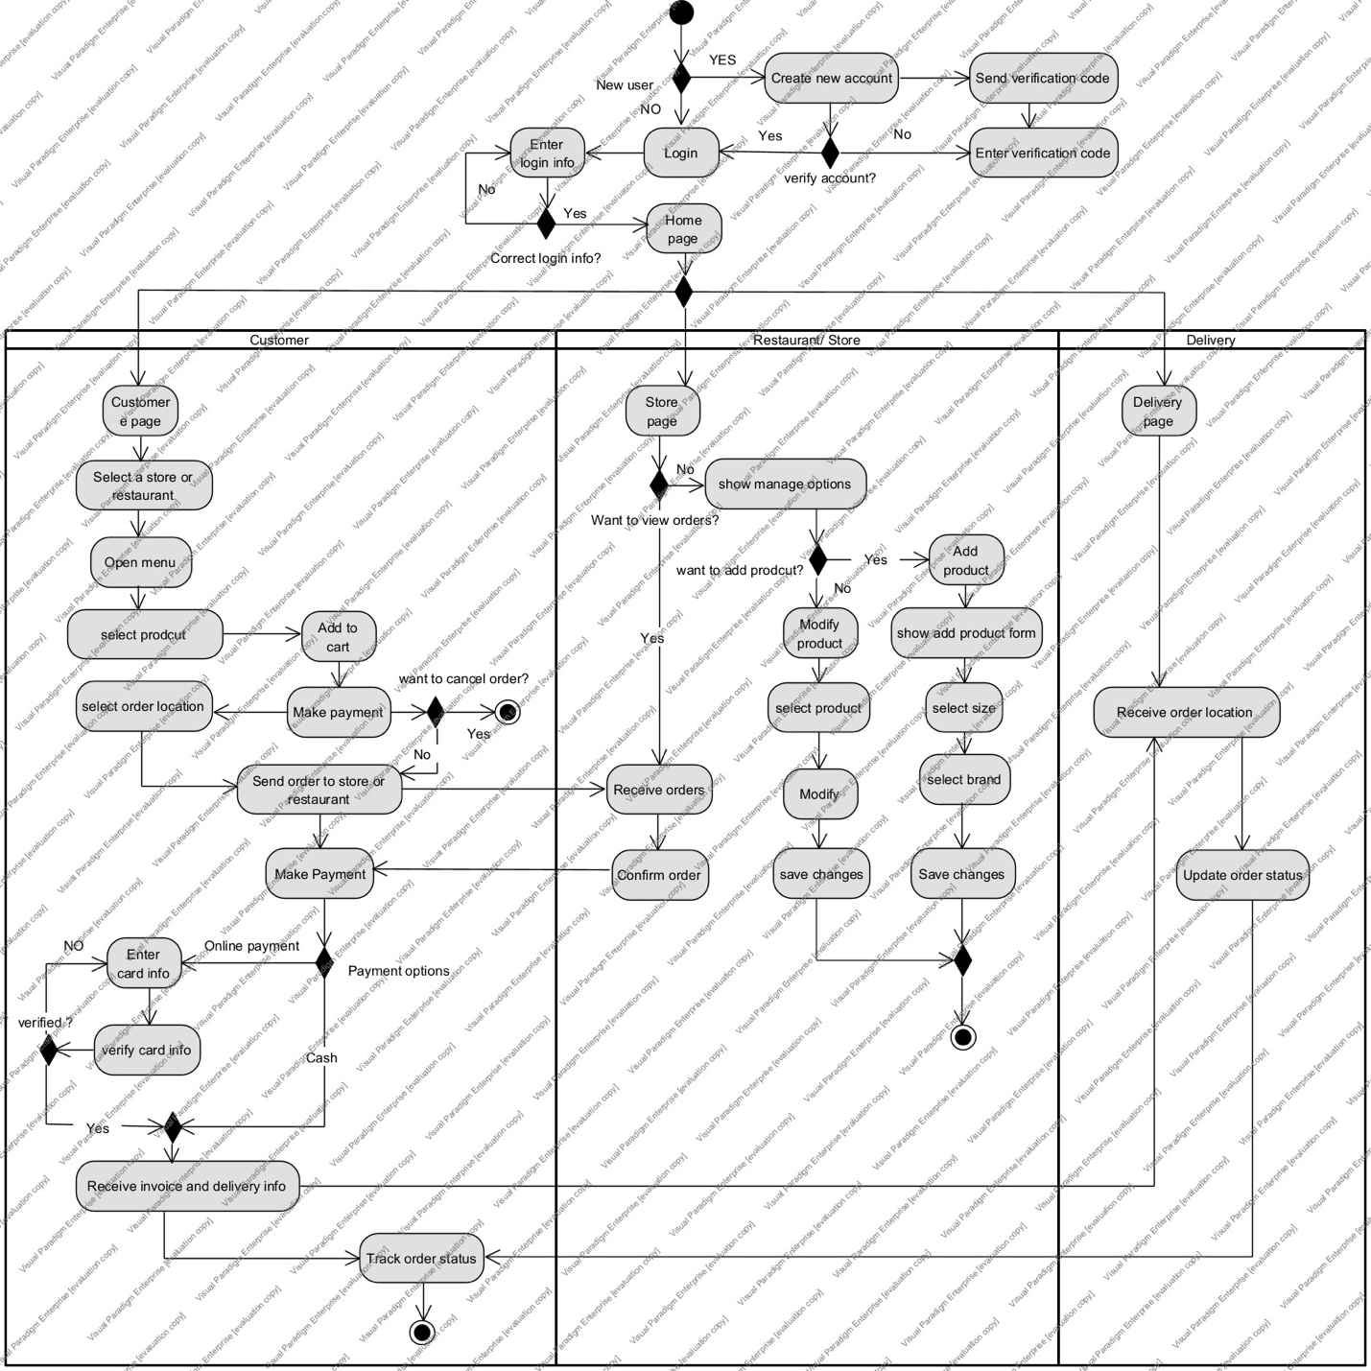

**Data Flow Diagrams**

**Context diagram**

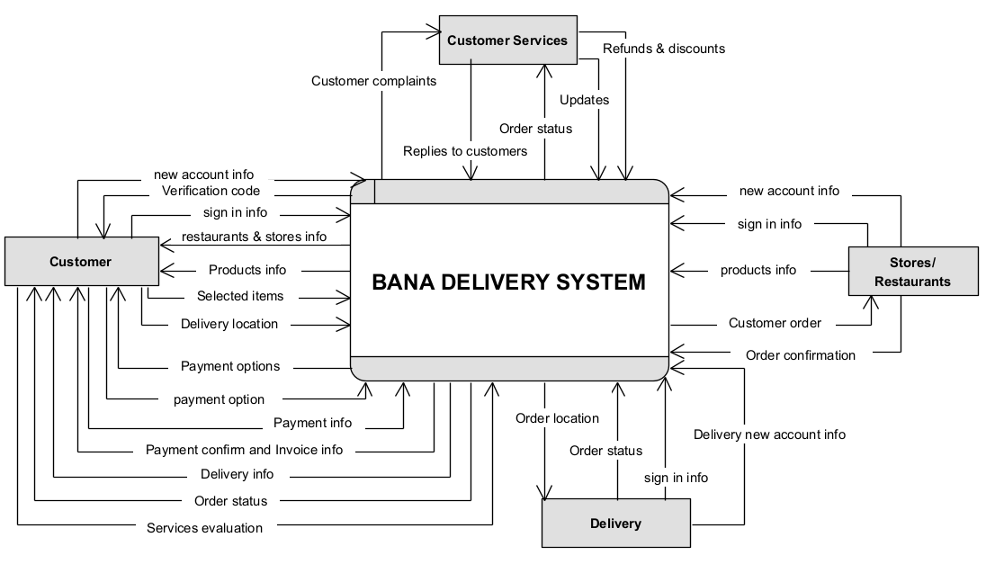

**Level-0 diagram**

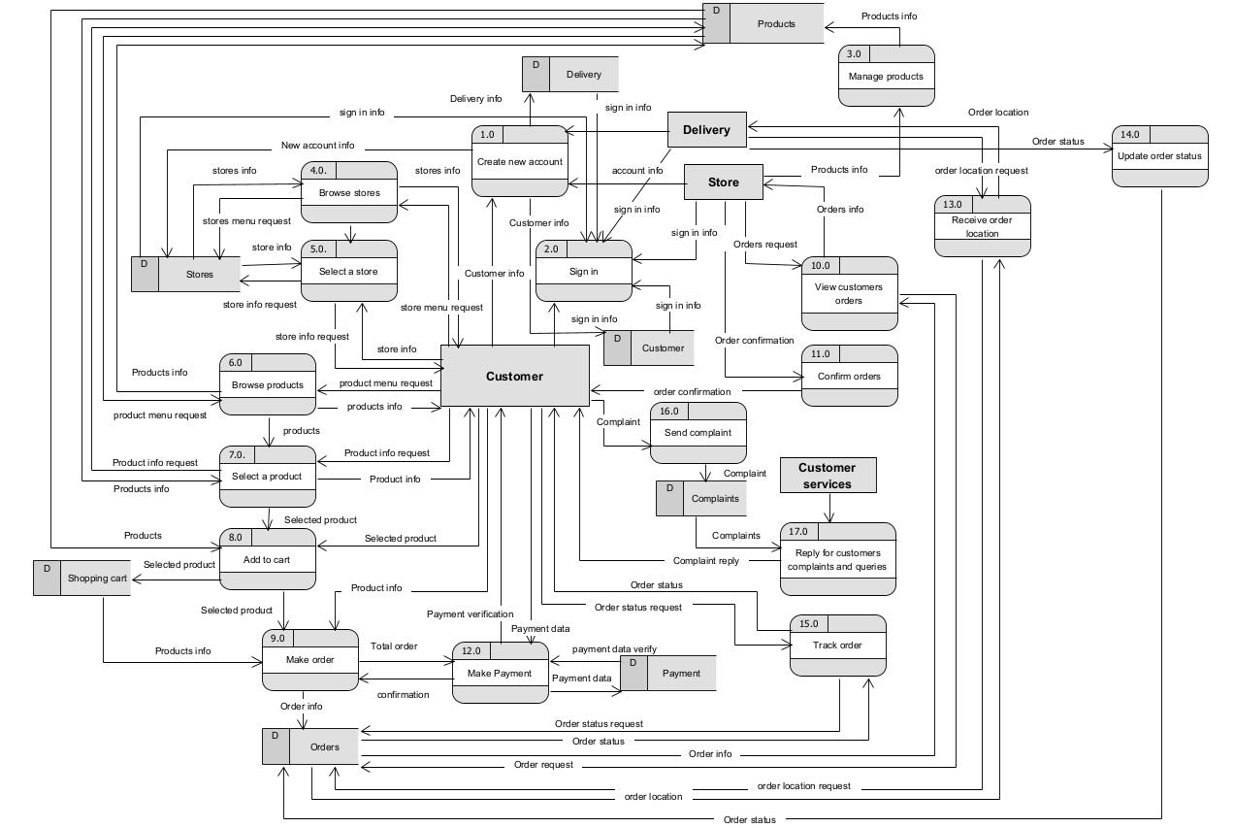

**Level-1 diagram**

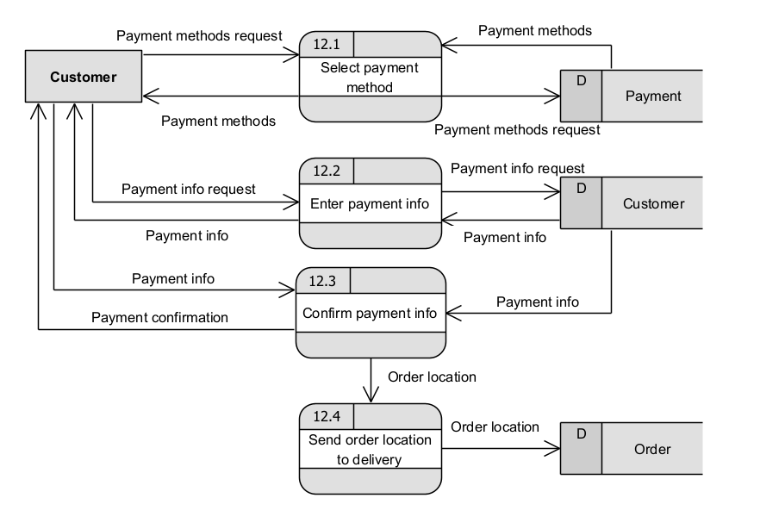

**ER diagramj**

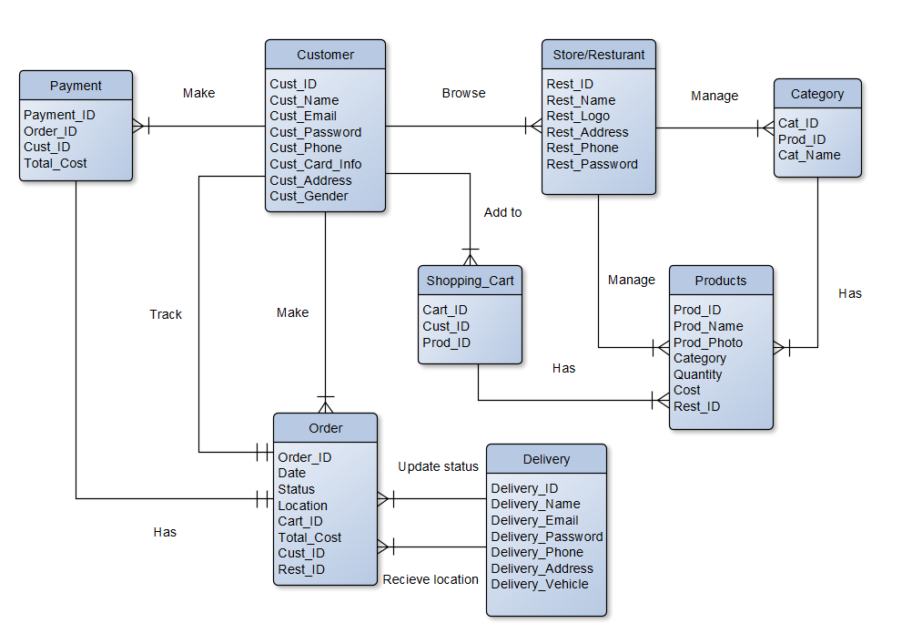

**Interfaces**

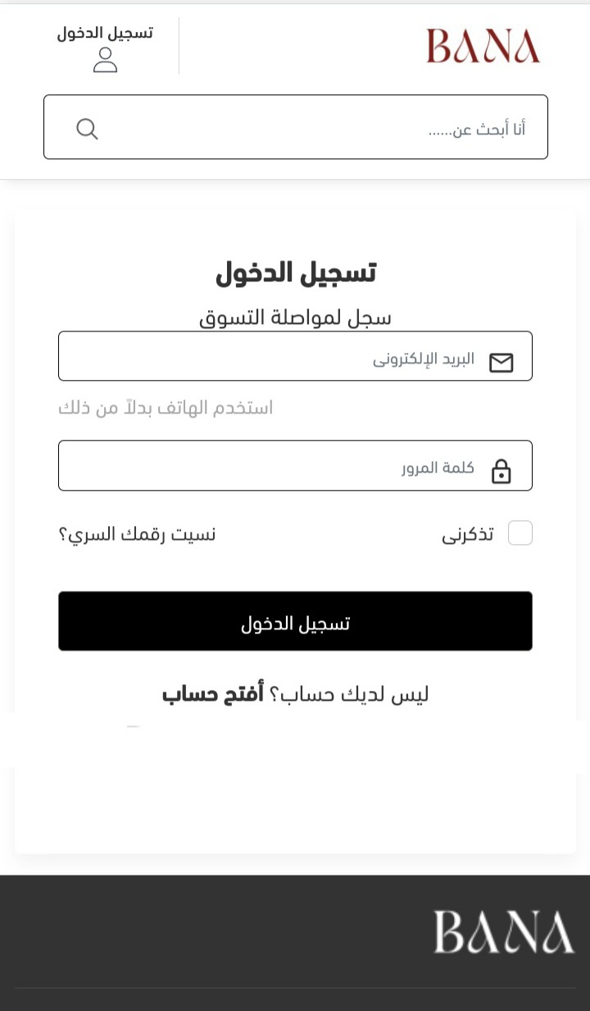

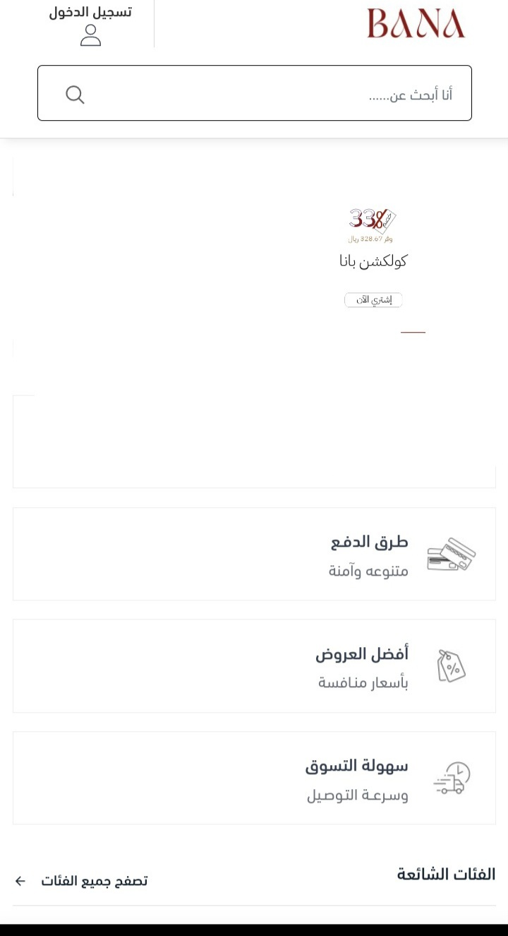

**References**

**.Gantt Chart from**

https://projectlibre.en.softonic.com/

**.Use case, DFD from**

https://www.lucidchart.com/pages/landing/diagram-tool · CANVA